# Controller Notes

1. Slow rise time of commanded power means output of PID running at 20ms cycle time will always be unstable, i.e. application of commanded power must be complete in < 20ms.

Figure 1 below shows the simulated time for the Typhoon HIL to achieve a commanded power of 1000kW (from a starting level of 0kW) is 334ms.

Figure – Delivered power rise time for default inverter settings.

* 1. This time can be decreased by modifying the inverter settings using Epyq as shown in Figure 2.

Figure

* 1. The resulting change in rise and fall times for demanded power are shown in Figure 3 and Figure 4, i.e. down to ~20ms.

Figure – Decreased rise time

Figure – Decreased fall time

1. Actual output power is lower than commanded and fluctuates as in Figure 5.

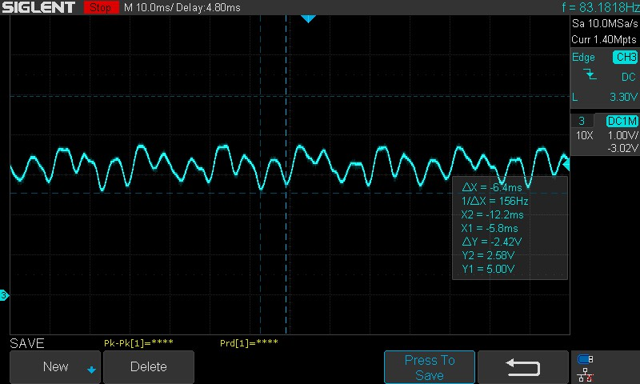

Figure

The commanded power in Figure 5 is 1000kW. The average power is 26kW lower than this, and deviates from this by ±6kW at a frequency of 150Hz.

* 1. I don’t think there is anything that can be done to control the 150Hz ±6kW fluctuation, as this is happening faster than the proposed meter (AcuVim II) can provide measurements, i.e. every 20ms.
  2. The average power can be maintained with a PID controller. After tuning PID, the following step transitions were measured.
     1. 0kW to 100kW, settling time 40ms.

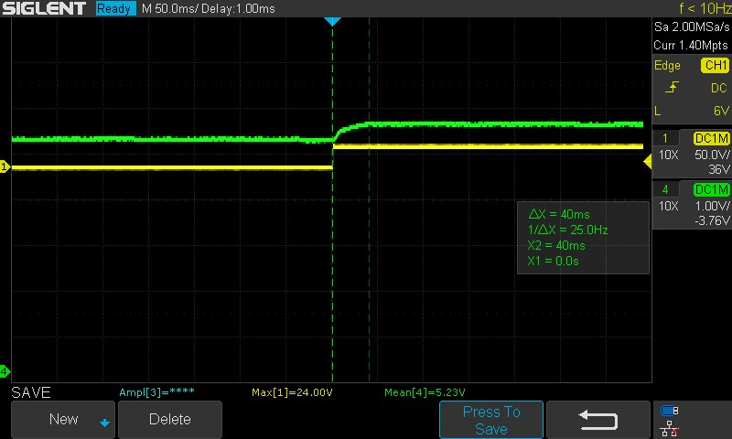

* + 1. 0kW to 500kW, settling time 40ms.

* + 1. -500kW to 500kW, settling time 60ms.

* + 1. -1000kW to 1000kW, settling time 72ms, with overshoot.

* + 1. Falling edge settling times and undershoot are not shown but are the equivalent of the rising edges in the plots above.

1. Dynamic Containment (DC)
   1. Frequency sweep, yellow trace (49.5Hz to 50.5Hz) versus power output, green trace (-1000kW to 1000kW).

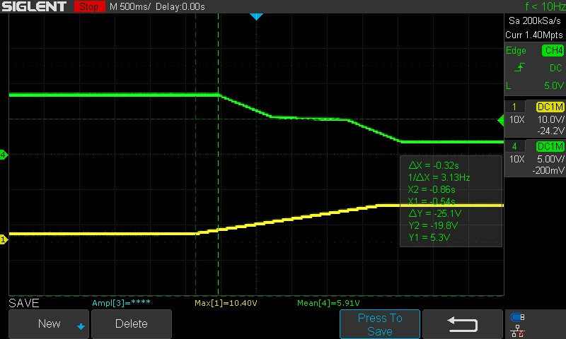

**Response delay = 320ms**

Power into grid

Power into battery

* 1. Dynamic containment Test 1.1 from National Grid spec:

Controller output:

* 1. Dynamic containment Test 1.2 from National Grid spec:

Controller output:

* 1. Dynamic containment Test 1.5 from National Grid spec:

Controller output (without PID activated) – response delay and ramp rate are within spec:

Controller output (with PID activated) – PID needs more tuning:

Added low-pass filter to power output of model, i.e. filtered power meter measurements. Filter parameters = 2.0Hz cut-off @ 20ms execution rate. PID parameters = 0.70, 10.00, 0.00:

* 1. Dynamic containment Test 1.6 from National Grid spec:
  2. Dynamic containment Test 1.7 from National Grid spec:

* 1. Dynamic containment Test 1.8 from National Grid spec:
  2. Dynamic containment Test 1.9 from National Grid spec:

* 1. Dynamic containment Test 1.10 from National Grid spec:
  2. Dynamic containment Test 1.11 from National Grid spec:

* 1. Dynamic containment Test 1.12 from National Grid spec:
  2. Dynamic containment Test 1.13 from National Grid spec:

1. General observations
   1. When in a frequency dependant mode, i.e., DC or FFR, when frequency approaches 50.5Hz, inverter switched from ‘FOLLOWING’ to ‘RIDE_THROUGH’. As power control is only applied during ‘FOLLOWING’ state, there is a noticeable delay in frequency response until ‘FOLLOWING’ is resumed. May need to consider changing frequency limits of inverter to prevent this happening.

TODO:

Add node IDs to CAN messages (maybe broadcast messages to all nodes).

Send CAN message to configure inverter for fast rise time.

Utilise NVR for storing PID parameters, etc, so they can be individually configured/stored and updated using commissioning tool.

Use LUT for setting initial power level and/or large steps in power demand to minimise settling times and overshoot from PID controller.

Modbus TCP